### BARCODE

***A Technical Seminar Report submitted***

***in partial fulfillment of***

***the requirements for the award of the Degree of***

## BACHELOR OF TECHNOLOGY

**in**

## INFORMATION TECHNOLOGY

**Submitted By**

## PONNA AKHIL: 17WJ1A1241



## DEPARTMENT OF INFORMATION TECHNOLOGY

**GURU NANAK INSTITUTIONS TECHNICAL CAMPUS (Autonomous)**

**(Affiliated to JNTUH, Accredited by NBA) Ibrahimpatnam, R. R. District, Telangana - 501506. (2017-2021)**

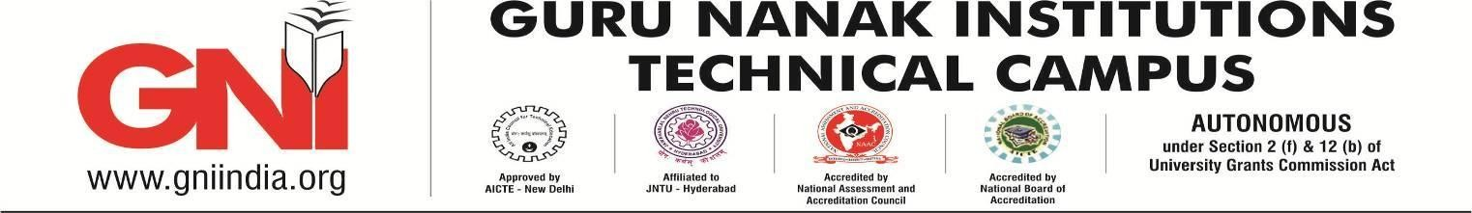

## DEPARTMENT OF INFORMATION TECHNOLOGY

**CERTIFICATE**

This is to certify that this technical seminar report entitled “ **Barcode** ” submitted by **PONNA AKHIL (17WJ1A1241),** in partial fulfillment of the requirements for the award of the degree of **Bachelor of Technology** in **Information Technology** prescribed by **Guru Nanak Institutions Technical Campus (Autonomous)** affiliated to Jawaharlal Nehru Technological University, Hyderabad during the academic year **2020 - 2021.** This Seminar report has been approved as it satisfies the academic requirements in respect to Technical Seminar prescribed for Bachelor Degree.

|  |  |  |
| --- | --- | --- |
| **Coordinator.** | **HOD** | **Associate Director** |
| Mr.Kiran Jeedi | Dr.M.I.Thariq Hussan | Dr.Rishi Sayal |

**External Examiner**

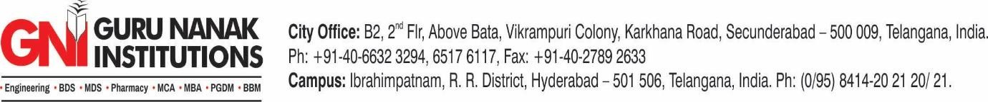

## ACKNOWLEDGEMENT

I wish to express our sincere thanks to **Sardar T.S.Kohli,** Chairman-GNITCand Chairman **Sardar G.S.Kohli** Vice-of Chairman-GNITCfor providing us all necessary facilities, resources and infrastructure for completing this technical seminar work.

I express a whole hearted gratitude to **Dr.H.S.Saini**, Managing Director-GNITC for providing strong vision in engineering education through accreditation policies under regular training in upgrading education for the faculty members.

I express a whole hearted gratitude to **Dr.M.Ramalinga Reddy,** Director-GNITCfor providing us the constructive platform to launch our ideas in the area of Information Technology and improving our academic standards.

I express a whole hearted gratitude to **Dr.Rishi Sayal,** Associate Director-GNITCfor providing us the conducive environment for carrying through our academic schedules and projects with ease.

I have been truly blessed to have a wonderful advisor **Dr.M.I.Thariq Hussan**, HOD- Department of Information Technology for guiding us to explore the ramification of our work and we express our sincere gratitude towards him for leading me throughout the technical seminar work.

I specially thank our internal guide **Mr.Kiran Jeedi**, Assistant Professor Department of Information Technology for his valuable suggestions and constant guidance in every stage of the technical seminar.

I express my sincere thanks to all the faculties of Information Technology department who helped us in every stage of our technical seminar by providing their valuable suggestions and support.

## DECLARATION

I hereby declare that the technical seminar report entitled “**BARCODE**” by **PONNA AKHIL (17WJ1A1241)** in partial fulfillment of the requirements for the award of the degree of **B.Tech** (**INFORMATION TECHNOLOGY)** submitted in the **Department of** **IT** is an authentic record of our work carried out during a period **March 2021-June2021.** The Matter presented in this thesis has not submitted by me in any other University/Institute for the award of any degree.

Date :

Place: GNITC

**Thanking you**

**PONNA AKHIL (17WJ1A1241)**



**Vision of the Department**

To be a premier Information Technology department in the region by providing

High quality education.

**Mission of the Department**

M1: Nurture young individuals into knowledgeable, skillful and ethical professionals in

their pursuit of Information Technology.

M2: Transform the students through excellent teaching learning process and sustain

High performance by innovations.

M3: Extensive partnerships and collaborations with foreign universities.

M4: Develop industry-interaction for innovation and product development.



**DEPARTMENT OF INFORMATION TECHNOLOGY**

**PROGRAMME EDUCATIONAL OBJECTIVES (PEOs)**

**PEO 1:** Produce industry ready graduates having the ability to apply academic knowledge across the disciplines and in emerging areas of Information Technology for higher studies, research, employability, product development and handle the realistic problems.

**PEO 2:** Graduates will have good communication skills, possess ethical conduct, sense of responsibility to serve the society and protect the environment.

**PEO 3:** Graduates will have excellence in soft skills, managerial skills, leadership qualities and understand the need for lifelong learning for a successful professional career.

**PROGRAMME OUTCOMES (POs)**

**Engineering Graduates will be able to:**

1. **Engineering knowledge**: Apply the knowledge of mathematics, science, engineering fundamentals, and an engineering specialization to the solution of complex engineering problems.
2. **Problem analysis**: Identify, formulate, review research literature, and analyze complex engineering problems reaching substantiated conclusions using first principles of mathematics, natural sciences, and engineering sciences.
3. **Design/development of solutions**: Design solutions for complex engineering problems and design system components or processes that meet the specified needs with appropriate consideration for the public health and safety, and the cultural, societal, and environmental considerations.
4. **Conduct investigations of complex problems**: Use research-based knowledge and research methods including design of experiments, analysis and interpretation of data, and synthesis of the information to provide valid conclusions.
5. **Modern tool usage**: Create, select, and apply appropriate techniques, resources, and modern engineering and IT tools including prediction and modeling to complex engineering activities with an understanding of the limitations.
6. **The engineer and society**: Apply reasoning informed by the contextual knowledge to assess societal, health, safety, legal and cultural issues and the consequent responsibilities relevant to the professional engineering practice.
7. **Environment and sustainability**: Understand the impact of the professional engineering solutions in societal and environmental contexts, and demonstrate the knowledge of, and need for sustainable development.
8. **Ethics**: Apply ethical principles and commit to professional ethics and responsibilities and norms of the engineering practice.
9. **Individual and team work**: Function effectively as an individual, and as a member or leader in diverse teams, and in multidisciplinary settings.
10. **Communication**: Communicate effectively on complex engineering activities with the engineering community and with society at large, such as, being able to comprehend and write effective reports and design documentation, make effective presentations, and give and receive clear instructions.
11. **Project management and finance**: Demonstrate knowledge and understanding of the engineering and management principles and apply these to one’s own work, as a member and leader in a team, to manage projects and in multidisciplinary environments.
12. **Life-long learning**: Recognize the need for, and have the preparation and ability to engage in independent and life-long learning in the broadest context of technological change.

**PROGRAMME SPECIFIC OUTCOMES (PSOs)**

1. Ability to design, develop, test and debug software applications, evaluate and recognize potential risks and provide innovative solutions.
2. Explore technical knowledge in diverse areas of Information Technology for upliftment of society, successful career, entrepreneurship and higher studies.

# ABSTRACT

Barcode technology is an automatic identification technology generated and developed in computer application and an effective means of data collection designed to achieve the automatic scanning of information. It is widely used in the logistics industry and typically used in the goods sale in supermarkets. At present, barcode management and identification system has been widely used in various types of supermarkets in the country. This article first introduces the use of bar code in domestic supermarkets and the technical characteristics and image recognition system of the maximum used EAN barcodes, proposing the corresponding barcode generation and identification methods based on image recognition technology. On this basis, the barcode generation and recognition software is developed. Feature of this study is that the recognition system can simultaneously generate and identify barcodes, so it can be more convenient and efficient for goods management and material circulation of medium, small supermarkets, specialty stores and other users. And it can be widely used in other areas, such as personnel management.

# 

# TABLE OF CONTENTS

|  |  |  |
| --- | --- | --- |
| **S.NO** | **TITLE** | **PAGE NO** |
| 1. | INTRODUCTION | 1 |
| 2. | HISTORY | 2-3 |
| 3. | IMPORTANCE(USAGE) | 4 |
| 4. | TYPES OF BARCODE  4.1 LINEAR TYPE  4.2 MULTI DIMENSIONAL | 5-14  5-10  10-14 |
| 5. | BARCODE REPRESNTATION | 15 |
| 6. | SCANNER | 16-19 |
| 7. | BARCODING GENERATION CODING  7.1 IMAGE GENERATION  7.2 PDF GENERATION  7.3 DATABASE CONNECTION AND  DYNAMIC BARCODE GENERATION  7.4 REFERENCE LIBRARIES | 20-27  20-21  21-23  24-27  28 |
| 8. | PRO’S AND CON’S | 29 |
| 9. | APPLICATION’S | 30 |
| 10 | CONCLUSION | 31 |
| 11 | REFERENCE | 32 |

# 1. INTRODUCTION

A barcode, consisting of bars and spaces, is a machine-readable representation of numerals and characters. Today, stripes as shown below on packages of products sold at supermarkets, convenience stores and other stores are ubiquitous. These are barcodes. A barcode consists of bars and spaces of varying width that can be read with an optical barcode scanner.

It is an automatic identification technology. It is a predefined format of DARK BARS and WHITE SPACES of varying width that can be read with an optical barcode scanner. Structured to contain a specific piece of information. In the barcode white space is considered as ZERO and black space as ONE. It allows real time data to be collected accurate and rapidly.

# 

# 2. HISTORY

Barcodes have been around for two generations, and as technology has Progressed their use has increased exponentially.

* 1948: The first Barcode was Invented by Norman J woodland and Bernard Silver. It is featured as bullseye design.
* 1952: Woodland and Silver received a patent for their invention, however technology Hurdles made it impractical.
* 1960: The Associate of American sponsors the KarTrak Barcode System. The size of a refrigerator featuring 13 horizontal labels.
* 1973: The committee on Uniform Grocery Product Code recommends barcodes is used on most products in U.S.
* 1974: On June 26, 1974, a pack of Wrigley’s gum became the first commercially-Scanned UPC barcode. The Code 29 is invented becoming the first alphanumeric Barcode technology.
* 1975: 90 % of all US rail cars KarTrak labels, although program would be abandoned 3 years later.
* 1986: The first handheld fixed-beam Laser scanner is patented.
* 1999: The two-dimensional QR code is unveiled in Japan.
* 2005: Airlines begin printing Barcode on passenger boarding pass to speed up the process.
* 2008: Mobile phones gain the required technology to be able to display barcode.
* 2016: The Digimarc Barcode, a machine –readable code nearly invisible to humans, is adoptable by the GS1 organization.
* Present: QR code is the most usage of 2-d barcode.

**3. IMPORTANCE (USAGE)**

* + - * When barcodes are used in the business process, procedures are automated.
      * To increase productivity and reduce human error.
      * ​Whenever there is a need to accurately identify or track something, bar- coding should be used.
      * ​ For example, in a data entry work environment, workers may be required to enter an enormous amount of data into a customer database system.
      * Instead of manually typing a customer identification number into a database, if the information is contained in a barcode, a data entry operation may scan it in.
      * ​Eliminate data entry errors
        + Errors due to bar code: less than 0.001%
        + Coded information errors: 1 every 1CR characters.
        + Manual information errors: 1 every 100 characters.

​

* + - * Easy and cheap to produce.

# 4. TYPES OF BARCODE

# 

# 4.1 LINEAR TYPE (1-D)

One-dimensional (or 1D) barcodes systematically represent data by varying the widths and spacing’s of parallel lines. These include some of the most traditional and well-recognized barcode types, such as the UPC and EAN codes. 1D barcodes are also commonly referred to as linear barcodes.

The length of a one-dimensional barcode is directly tied to how much information it holds. Consequently, users must limit the number of characters each code contains from 8 to 15. 1D barcodes are commonly used across enterprise operations to save time and make inventory workflows more efficient.

**4.1.1 UPC CODE**

UPC barcodes are used to label and scan consumer goods at points of sale around the world—mainly in the United States, but also in the United Kingdom, Australia, New Zealand and other countries. The UPC-A variation encodes twelve numerical digits, while UPC-E is a smaller variation that encodes only six numerical digits.

UPC actually stands for universal product code. In the context of retail, the purpose of this barcode is to make it easy for users to identify specific product features (like its size or color) when an item is scanned at checkout. Along with making the checkout process more efficient, UPC codes help streamline inventory tracking within stores and warehouses. UPCs enable accurate and efficient product tracking all the way through production to distribution.

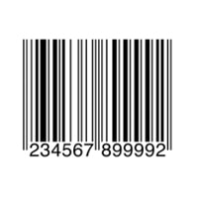Industry: Retail

Variations: UPC-A, UPC-E

**4.1.2 EAN CODE**

EAN barcodes are also used to label consumer goods worldwide for point-of-sale scanning, primarily in Europe. They look very similar to UPC codes, and the main distinction is their geographical application. While EAN-13 (comprising 13 digits) is the default form factor, you’ll find EAN-8 (covering eight digits) barcodes on products where space is limited, like small candies.

The main advantage of EAN codes is their flexibility. EAN-13 is a high-density barcode that can encode relatively large amounts of data in a small area—while EAN-8 codes are ideal for identifying very small products or assets. EAN codes are also easy for 1D scanner to read, making the scanning process fast and seamless.

Industry: Retail

Variations: EAN-13, EAN-8, JAN-13, ISBN, ISSN

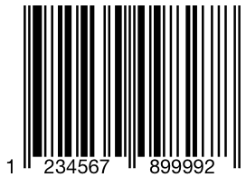

**4.1.3 CODE 39**

Code39 barcodes (or Code 3 of 9) are used to label goods across many industries and are often found in the automotive industry and the U.S. Department of Defense. It enables the use of both digits and characters, and its name originates in the fact that it could only encode 39 characters—though in its most recent version, the character set has been increased to 43. It’s similar to, but not as compact as, the Code 128 barcode.

One limitation of Code39 is its relatively low data density. The size required for these barcodes makes them ill-suited for very small goods and assets. However, Code39 remains a popular and versatile choice, namely because it eliminates the need to generate a check digit—and can be decoded by almost any barcode reader.

Industry: Automotive and Defense

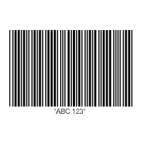

**4.1.4 CODE 128**

Code 128 barcodes are compact, high-density codes used in logistics and transportation industries for ordering and distribution. They’re geared toward non-POS products, like when supply chain applications label units with serial shipping container codes (SSCC). Because they support any character of the ASCII 128 character set, Code 128 barcodes can store highly diversified information.

The greatest advantage of Code 128 is its high data density. These barcodes can store large amounts of linear data in compact form, making them ideally suited for identifying shipped or packaged containers and items. These strengths make Code 128 barcodes a natural choice for shipping and supply chain operations.

Industry: Supply Chain

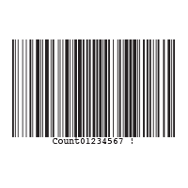

**4.1.5 ITF (INTERLEAVED 2 OF 5)**

ITF (or Interleaved 2 of 5) barcodes are used to label packaging materials across the globe. Since they can deal with high printing tolerances, they are ideal for printing on corrugated cardboard. ITF barcodes encode 14 numeric digits and use the full ASCII set.

One of the greatest strengths of Interleaved 2 of 5 is that its printed tolerances are suited for corrugated cardboard. As a result, this self-checking code is a powerful tool for encoding information on product packaging. While the Interleaved 2 of 5 barcode can only encode numbers (not letters), it does not require a check digit.

Industry: Packaging

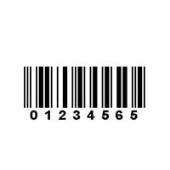

**4.1.6 CODE 93**

Code 93 barcodes are used in logistics to identify packages in retail inventory, label electronic components, and even provide supplementary delivery information for the Canadian Post. Like Code 39, Code 93 barcodes come with full ASCII support. Along with enabling additional security within the code itself, the high density and compact size of Code 93s make them around 25% shorter than barcodes produced in Code 39.

Code 93 acts as a more compact and secure alternative to Code 39, partly thanks to its additional characters. Its small size and data redundancy make it ideal for use across a wide range of industries, from automotive to retail and logistics.

Industry: Retail, Manufacturing and Logistics

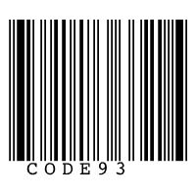

**4.1.7 CODE BAR**

Code bar barcodes are used by logistics and healthcare professionals, including U.S. blood banks, FedEx, photo labs and libraries. Their main benefit is that they’re easy to print and can be produced by any impact style printer—even a typewriter. Therefore, users can create many Codabar codes

using consecutive numbers without the use of a computer. Codabar is a discrete, self-checking symbology that encodes up to 16 different characters with an additional 4 start/stop characters.

Advantages of Codabar barcodes include ease of scanning and self-checking, which reduces errors when entering the code. However, Codabar codes are being phased out in favor of newer code forms, which allow more data to be stored in a much smaller form. Regardless, Codabar is still commonly used across logistics, healthcare and even schools, where the code is applied to the spines of library books.

Variations: Codabar, Ames Code, NW-7, Monarch, Code 2 of 7, Rationalized Codabar, ANSI/AIM BC3-1995, USD-4

Industry: Logistics, Healthcare and Education

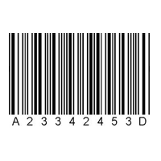

**4.1.8 GS1 DATABAR**

GS1 DataBar barcodes (formerly known as Reduced Space Symbology) are used by retail outlets to identify consumer coupons, produce and perishables, as well as small objects in the healthcare industry. They are more compact than typical consumer-facing barcodes. GS1 DataBar was introduced in 2001 and has become the mandated barcode type for retail coupons in the U.S.

GS1 DataBar codes offer many potential benefits. For example, leading retailers use these compact tools to reduce point-of-sale transaction times. GS1 codes also support faster and more enjoyable checkout experiences for customers at self-checkout stations. These codes also support faster and more efficient scanning workflows in patient care environments.

Variations: GS1 DataBar Omnidirectional, Truncated, Stacked, Stacked Omnidirectional, Expanded, Expanded Stacked

Industry: Retail and Healthcare



**4.2 MULTI DIMENSIONAL (2-D)**

Two-dimensional (or 2D) barcodes systematically represent data using two-dimensional symbols and shapes. They are similar to a linear 1D barcode, but can represent more data per unit area. 2D barcodes include some newer barcode types, such as the QR Code and PDF417.

Another key advantage of 2D barcodes is their error-protection formulas. These codes are designed to keep data intact and scan able—even after being ripped, scratched or damaged. This feature makes 2D barcodes uniquely suited to more intense, fast-paced scanning applications.

**4.2.1 QR CODE**

QR codes are most often used in tracking and marketing initiatives, such as advertisements, magazines and business cards. They are flexible in size, offer a high fault tolerance and have fast readability, though they can’t be read with a laser scanner. QR codes support four different modes of data: numeric, alphanumeric, byte/binary, and even Kanji. They are public domain and free to use.

QR codes offer exceptional versatility. They can be scanned on just about any device with scanning capabilities (including inexpensive smartphones)—and encode almost any type of data. QR codes also feature exceptional fault tolerance, allowing users to decode information even if part of the code is damaged.

Industry: Retail, Entertainment and Advertising



**4.2.2 DATAMATRIX CODE**

Datamatrix codes are usually used to label small items, goods and documents. Their tiny footprint makes them ideal for small products in logistics and operations. In fact, the U.S. Electronic Industries Alliance (EIA) recommends that they be used to label small electronic components.

Similar to QR codes, they have high fault tolerance and fast readability.

Datamatrix codes offer high data density, which means they take up less space on products and assets. They’re also designed to be readable even in low resolution or with unideal scanning positions. Like many other 2D barcodes, Datamatrix codes offer strong fault tolerance as well.

Variation: Micro-Datamatrix

Industry: Electronics, Retail and Government

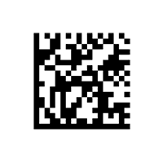

**4.2.3 PDF417 CODE**

PDF417 codes are used for applications that require the storage of huge amounts of data, such as photographs, fingerprints and signatures. They can hold over 1.1 kilobytes of machine-readable data, making them much more powerful than other 2D barcodes. Like QR codes, PDF417 barcodes are public domain and free to use.

Thanks to their data efficiency, PDF417 codes are suited to a wide variety of applications, including transport and inventory management. These barcodes are also well suited for creating paper boarding passes, as well as state-issued identification cards.

Variation: Truncated PDF417

Industry: Logistics and Government



**4.2.4 AZTEC CODE**

Aztec codes are commonly used by the transportation industry, particularly for tickets and airline boarding passes. The barcodes can still be decoded even if they have bad resolution, making them useful when tickets are printed poorly or presented on a phone. They can also take up less space because they don’t require a surrounding blank “quiet zone,” unlike some other 2D barcode types.

Aztec barcodes are extremely space-efficient. They can hold massive amounts of data while maintaining a relatively small size—and features excellent error correction to prevent scanning errors. And while these codes don’t support the same range of characters as QR codes, they remain a powerful tool for transportation, healthcare and other industries.

Industry: Transportation



# 5. BARCODEREPRESENTATION

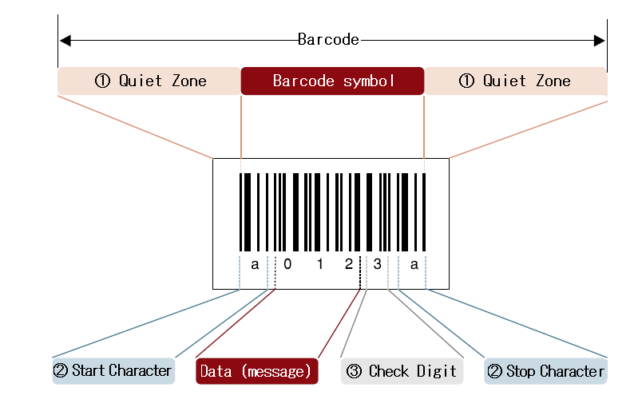

* Each barcode label have a few different parts:
* Manufacture's ID
* Product Item Number
* Check Digit
* Each product has a unique product Item Number.
* Check Digit is the final number of the barcode label when scanner reads the barcode, the digit helps it to verify that the barcode has been read correctly.
* This is all done by scanner.
* Which pickups the bars then it transfer the information to the computer.

**6. SCANNER**

# 



* These are an electronic device to read printed barcodes.
* A barcode scanner uses a PHOTO SENSOR (OPTICAL TECHNIQUE).
* To convert the barcode into an electric Signal.
* Type

**A. Pen Style Scanners**

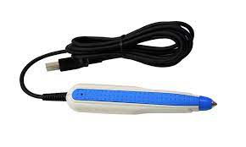

Wand Barcode Scanner is the simplest and lease expensive type of Barcode Scanner. Because of their simple design (no moving parts), Wand Barcode Scanners are the most durable type of barcode scanner,

and can be tightly sealed against dust, dirt, and other environmental hazards. Wand Barcode Scanners are limited because they must come into direct contact with a barcode to read it. Because of their small size and low weight, Wand Barcode Scanners are ideally suited to portable (laptop) or very low volume scanning applications.

**B. Slot Based Scanners**

The system uses slot scanning geometry to acquire the radiography without the use of an anti-scatter grid. The narrow fan-like beam is synchronized with the detector when scanning a patient. As a result, the image data are obtained from the detector as the patient is scanned via the time consuming method.

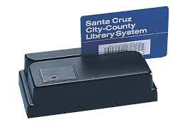

**C. Charge Coupled Device**

CD (Charge Coupled Device) scanners are similar to digital cameras in that they have hundreds of tiny LED lights arranged in one long row that capture a digital image of the barcode. They generally have very fast scan rates but limited read ranges (less than 3 inches) compared to a laser or imager scanners. CCD scanners are also lower cost than other scanner types making them a great choice for point-of-sale and lower volume scanning applications where distance reading is not a concern.

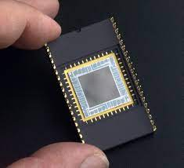

**D. Camera Based Scanners**

A webcam barcode scanner allows you to encode many types of barcodes by using a webcam installed on your terminal. ... Who is struggling with a new business and want to resize the costs you can use a system completely free which allows turning a simple webcam into a barcode reader.

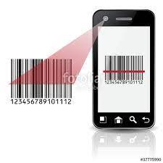

**E. Laser Based Scanners**

A barcode scanner, or barcode reader, is a device with lights, lenses, and a sensor that decodes and captures the information contained in barcodes. In the early days of 1D code, codes could only be read by lasers. Laser scanners use a laser beam as a light source and typically employ oscillating mirrors or rotating prisms to scan the laser beam back and forth across the barcode.

A photodiode then measures the reflected light from the barcode. An analog signal is created from the photodiode, and is then converted into a digital signal.

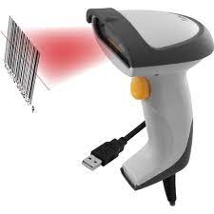

# 7. BARCODE GENERATION CODING

**7.1 IMAGE GENERATION**

import java.awt.image.BufferedImage;

import java.io.ByteArrayOutputStream;

import java.io.FileOutputStream;

import org.krysalis.barcode4j.impl.code128.Code128Bean;

import org.krysalis.barcode4j.output.bitmap.BitmapCanvasProvider;

public class Image {

    public static void main (String [] args) {

        Image.createImage ("Barcode.png", "AKHIL");

        System.out.println ("finished");

    }

    public static void createImage (String image_name, String myString)

{

        try {

        Code128Bean code128 = new Code128Bean ();

        code128.setHeight (15f);

        code128.setModuleWidth (0.3);

        code128.setQuietZone (10);

        code128.doQuietZone (true);

        ByteArrayOutputStream baos = new ByteArrayOutputStream ();

        BitmapCanvasProvider canvas = new BitmapCanvasProvider (baos, "image/x-png", 300, BufferedImage.TYPE_BYTE_BINARY, false, 0);

        code128.generateBarcode (canvas, myString);

        canvas.finish ();

//write to png file

      FileOutputStream fos = new FileOutputStream ("C:\\Users\\ponna Akhil\\Desktop\\barcode\\"+image_name);

        fos. Write (baos.toByteArray ());

        fos. Flush ();

        fos. Close ();

        } catch (Exception e) {

            // TODO: handle exception

        }

    }

}

# 

# 

# 

# 

# 7.2 PDF GENERATION

import java.io.FileOutputStream;

import com.itextpdf.text.Document;

import com.itextpdf.text.DocumentException;

import com.itextpdf.text.Image;

import com.itextpdf.text.PageSize;

import com.itextpdf.text.pdf.Barcode128;

import com.itextpdf.text.pdf.BarcodeEAN;

import com.itextpdf.text.pdf.PdfContentByte;

import com.itextpdf.text.pdf.PdfWriter;

public class PDF {

public static void main (String [] args) {

PDF. createPDF ("Barcode.pdf","akhil");

System.out.println ("Barcode is created in pdf format");

}

public static void createPDF (String pdfFilename, String myString) {

Document doc = new Document ();

PdfWriter docWriter = null;

try {

docWriter = PdfWriter.getInstance (doc, new FileOutputStream ("C:\\Users\\ponna Akhil\\Desktop\\barcode\\"+pdfFilename));

doc.addAuthor ("jinujawad");

doc.addCreationDate ();

doc. addProducer ();

doc. addCreator ("chillyfacts.com");

doc. addTitle ("chillyfacts Barcode test");

doc.setPageSize (PageSize.LETTER);

doc.open ();

PdfContentByte cb = docWriter.getDirectContent ();

Barcode128 code128 = new Barcode128 ();

code128.setCode (myString.trim ());

code128.setCodeType (Barcode128.CODE128);

Image code128Image =

code128.createImageWithBarcode (cb, null, null);

code128Image.setAbsolutePosition (10, 700);

code128Image.scalePercent (125);

doc. add (code128Image);

BarcodeEAN codeEAN = new BarcodeEAN ();

codeEAN.setCode (myString.trim ());

codeEAN.setCodeType (BarcodeEAN.EAN13);

Image codeEANImage =

code128.createImageWithBarcode (cb, null, null);

codeEANImage.setAbsolutePosition (10, 600);

codeEANImage.scalePercent (125);

doc. Add (codeEANImage);

} catch (DocumentException dex)

{

dex.printStackTrace ()

} catch (Exception ex) {

ex.printStackTrace ();

} finally

{

if (doc! = null) {

doc.close ();

}

if (docWriter! = null) {

docWriter.close ();

}

}}

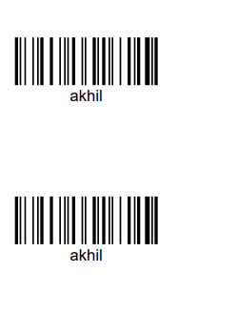

**7.3DATABASE CONNECTION AND DYNAMIC BARCODE**

**GENERATION**

**7.3.1 DATABASE CONNECTION**

import java.sql.Connection;

import java.sql.DriverManager;

public class DBConnection {

public Connection getConnection (){

Connection connection=null;

System.out.println ("Connection called");

try {

Class.forName ("com.mysql.jdbc.Driver");

Connection=

DriverManager.getConnection("jdbc:mysql://localhost:3306/Barcode","root", "15036244");

} catch (ClassNotFoundException e) {

e.printStackTrace ();

} catch (Exception e) {

e.printStackTrace ();

}

return connection;

}

}

**7.3.2 DYNAMIC BARCODES**

import java.sql.Connection;

import java.sql.PreparedStatement;

import java.sql.ResultSet;

import DBconnection.DBConnection;

import image.Image;

import Pdf.PDF;

@SuppressWarnings ("unused")

public class Generate_Dynamic_Barcode {

public static void main (String [] args) throws ClassNotFoundException {

             PreparedStatement ps=null;

            Connection connection=null;

            DBConnection obj_DBConnection=new

DBConnection ();

            connection=obj_DBConnection.getConnection ();

            ResultSet rs=null;

        try {

            String query="select * from user";

            ps = connection.prepareStatement (query);

            rs=ps.executeQuery ();

            while (rs.next ())

{

                Image.createImage (rs.getString ("Name") +".png", rs.getString ("Mobile"));

                PDF.createPDF (rs.getString ("Name")+".pdf", rs.getString("Name"));

                System.out.println ("Creating Barcode for "+rs.getString ("Mobile"));

}

}

Catch (Exception e)

{

            e.printStackTrace ();

        }

Finally {

            if (connection! =null){

                try {

                        connection. Close ();

                    }

                 catch (Exception e2) {

                    e2.printStackTrace ();

                }

            }

            if (ps! =null){

                try {

                    ps. close ();

                    }

                 catch (Exception e2) {

                     e2.printStackTrace ();

                }

            }

        }

        }

}

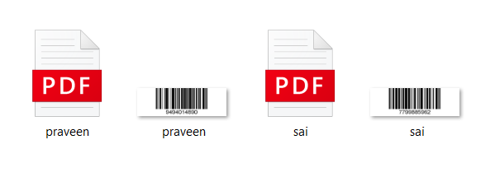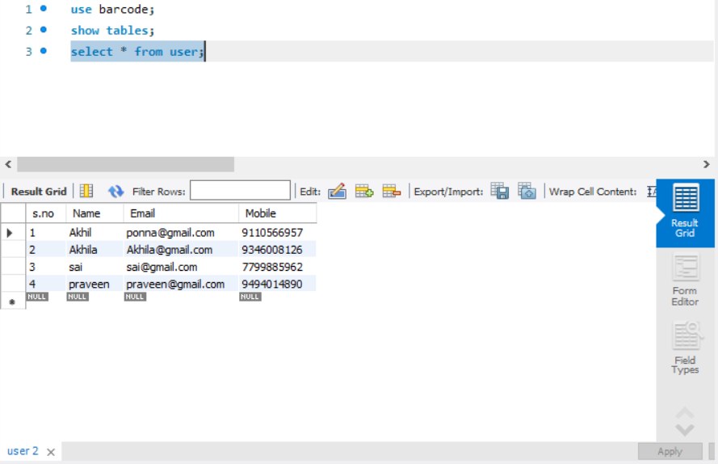

**7.4 REFERENCE LIBRARIES**

* BARCODE4J.JAR
* ITEXTPDF-5.1.0.JAR
* MYSQL-CONNECTOR-JAVA-8.0.23.JAR

# 8. PRO’S AND CON’S

**PRO’S:**

* Represent unique identity of a product.
* Accuracy of data input (Error Free).
* More accurate dispatch.
* Cost efficient.
* Real time data collection.
* Measurement of work in progress throughout the factory.
* Rapid access to total cost productions

**CON’S**

* System failure may costs more delay
* Scratched barcodes may cause problems
* Data must be stored in the barcode
* In laser scanning cost and durability are the  two disadvantages

# 9. APPLICATION’S

# Departmental stores

# Library

# Industries

# Health agencies

# Document tracking

# 10. CONCLUSION

Business industries and stores around the world, flourished due to, the purpose of barcodes, types of barcodes, as well as the way barcodes gathered and transfer information. A quick blurb about what happened is that the differences between 1D and 2D barcodes are tremendous and work for different purposes.  Same as the barcodes, some of the scanners are different because of the code they are scanning.  barcodes also help with management and their point of view.  Now you may realize how big of an effect barcodes make in our lives and how each product has a different barcode out of thousands.  It will change our future because everything we would ever need would be right at our fingertips.

# 11. REFERENCE

# 

# Scandit Website

# (<https://www.scandit.com/blog/types-barcodes-choosing-right-barcode>)

# Wikipedia

# (<https://en.wikipedia.org/wiki/Barcode>)

# Wasp Barcode Technologies

# (<https://www.waspbarcode.com/buzz/barcode>)

# 